The Nature of Ballymun: Evaluation of the Ballymun Biodiversity Action Plan

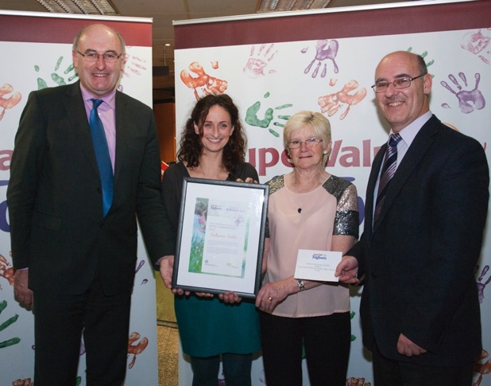

Representatives from Ballymun being presented with the national award for biodiversity in the 2013 Tidy Towns competition with the Minister for the Environment, Community and Local Government

Prepared for Dublin City Council Parks and Landscape Services Section and Ballymun Regeneration Ltd

Mary Tubridy and Associates April 2014

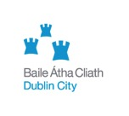

CONTENTS

Summary and Recommendations
Acknowledgements

1 Background and policy context

1.1 Project aims 6
1.2 Ballymun Biodiversity Action Plan 7
1.3 Implementation of the Biodiversity Action Plan 7
1.4 Related initiatives 19
1.5 Policy context 22

2 Evaluation methodology

2.1 Introduction 30
2.2 Desk research 30
2.3 Consultations 30
2.4 Fieldwork 31
2.5 Constraints 32
2.6 Outputs 33

3 Results

3.1 The current status of biodiversity 34
3.2 Community awareness of biodiversity 42
3.3 Gardening, community gardening and allotments 44
3.4 Implementation of statutory objectives
for biodiversity in Ballymun 45
3.5 Weaknesses/threats to biodiversity management 45
3.5 Trends 46

4 Conclusions

4.1 Impact of the Biodiversity Action Plan 48
4.2 Opportunities for Ballymun 50
4.3 Lessons from the evaluation 55

References

Appendix 1 Biodiversity awards achieved by Ballymun
Appendix 2 Relevant policies in Dublin City Development Plan 2011-2017
Appendix 3 List of consultees
Appendix 4 Sample of Ballymun habitat map
Appendix 5 Preliminary review of biodiversity in Sillogue Golf Course
Appendix 6 Birds in Poppintree July 2013

Summary and recommendations

The report contains an assessment of the impact of the Ballymun Biodiversity Action Plan and recommendations to maintain improvements to biodiversity. Habitat mapping was carried out to determine the nature of overall changes in biodiversity in Ballymun since 2007 and to inform a preliminary assessment of biodiversity in Sillogue Golf Course. A bird survey was carried out in Poppintree. Its ponds were surveyed for newts. Semi-structured interviews (15) were carried among a sample of local stakeholders. Habitat mapping showed that biodiversity had significantly improved since 2007. This was largely due to the development of wildflower meadows, the presence of new wetland habitats in Poppintree and evidence for the increasing diversity of bird species. Awareness of biodiversity among residents had significantly improved. This was not surprising as the enhancement of biodiversity had resulted from a range of initiatives carried out within the community in partnership with the statutory authorities. Gap was the principal organisation responsible for delivering biodiversity/ education programmes, to householders, in primary schools, with youth and unemployed people. Garden competitions were run by BRL in conjunction with the National Botanic Gardens. A newly established Tidy Towns Group supported by BRL was actively involved in biodiversity enhancement projects. Nature trails and tree guides for local parks were produced in association with the Parks Department Dublin City Council and a Green Map of Ballymun highlighted areas of biodiversity interest. Other significant projects included the establishment of two community gardens and the development of a Parks Stewardship Programme which links schools and parks through environmental education activities. The improvements in biodiversity in Ballymun have been recognized through the Tidy Towns competition. Ballymun won the Dublin award for biodiversity in the Tidy Towns competition between 2010 and 2012 and the national award for biodiversity in the Tidy Towns competition in 2013.

Lessons from the review are that
- Any plan to improve biodiversity should have a time limited set of actions and be developed following field studies by a specialist ecologist/ environmentalist.
- Actions should focus on the involvement of the community through schools and parks based activities, environmental education exercises and gardening, including the development of valuable habitats.
- The plan should be administered within a framework which has the mandate and resources (personnel and capital budget) to support the delivery of the required actions.
- A facilitator/coordinator is needed and a spatially focused implementation group should be set up with representatives of the authorities, the community and delivery bodies. It should meet regularly and thus provide a forum for evaluation, discussion and support for all types of biodiversity related activities, not only those contained in an action plan.

These lessons suggest that the roll out of similar initiatives elsewhere require the following supports:
- A minimum budgetary allocation of at least €1/ per person/year.
- Effective statutory and administrative frameworks.
- A partnership approach between the authorities and various sectors within the community.

Acknowledgements

Thanks are due to everyone who assisted in the preparation of this report particularly the respondents to the questionnaire.

Roger Warburton and Dorothea Burger (BRL); Maryann Harris, (Dublin City Council), and Lynn Boylan, Vanessa Moore and Maire Hurley (GAP) were particularly helpful as they provided details of the work programme over the last five years.

Ordnance survey mapping was supplied under license from Dublin City Council and Fingal County Council (Sillogue).

1 Background and policy context

1.1 Project aims

According to the brief agreed with BRL and the Parks Department, the study report should focus on:

- A review of implementation of the Ballymun BAP to ensure learning and actions associated with it continue to contribute to biodiversity management in Ballymun, the city and region.

- Providing additional information on particular aspects of biodiversity which is necessary to plan future action. These include 1) a preliminary review of biodiversity and its potential for management in Sillogue Golf Course and land containing adjacent allotments and 2) surveys of newts and breeding birds in Poppintree Park.

The area covered by the first Biodiversity Action Plan is shown in Fig. 1.

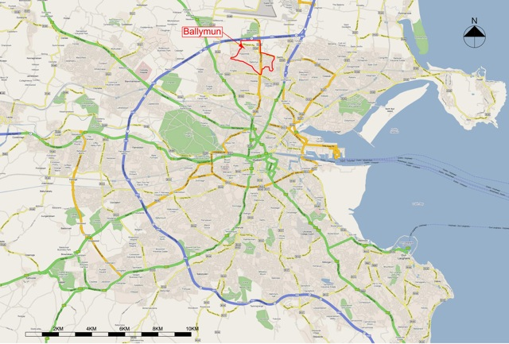

Fig. 1 Location of Ballymun

1.2 Ballymun Biodiversity Action Plan

The first Ballymun BAP (BRL, 2008) was published in 2008. Its production involved fieldwork in 2007 to produce a habitat map and a list of birds in Ballymun. The BAP contained a five year work programme, listing actions to be carried out in the short term, medium term, and long term under six themes:
- Increase awareness and enjoyment
- Carefully manage areas of high biodiversity value
- Enhance biodiversity in public spaces and institutional lands (schools, churches etc.)
- Encourage and support all developers, householders and gardeners to take small actions to enhance biodiversity
- Monitor the successful implementation of the plan and improvements in biodiversity
- Disseminate the results of biodiversity actions to other communities

The BAP built on the work which was being carried out by 1) Global Action Plan to provide environmental education in schools and support householders to gardening skills and 2) the development of new parks which were designed to enhance biodiversity. GAP Ireland is part of an international organisation which works to implement Agenda 21 through community action. Its work in Ballymun is managed through a service level agreement with Dublin City Council and BRL.

1.3 Implementation of the Ballymun Biodiversity Action Plan

The implementation of the BAP was coordinated by an environmental manager in BRL through an Implementation Group which contained representatives of BRL (planning, parks and environment), GAP’s environmental scientist and DCC (Parks and Landscape Services Section) staff. Following publication of the BAP, GAP recruited a specialist with experience of environmental education.

Twice yearly meetings focused on delivery of actions listed in the BAP. These meetings were minuted by BRL. Based on these minutes and local consultations information was compiled on the actions undertaken under the BAP. These are shown in Table 1. Within this table, are listed by theme and information is provided on the recommended timetable for the relevant action, the nature of the action and the people/ organisations who should be involved. The final column (in red) describes how the action was implemented.
Table 1 Review of Ballymun BAP: Actions and Results

Theme One: To increase Awareness and Enjoyment of Biodiversity

Timescale | Action in BAP | Who should be involved? | Result of BAP
Year One  2009-2010  Years 3-5  2011-2013 | Bioblitz in Ballymun during Biodiversity Week (week of May 22nd). A “bioblitz” brings together “experts” and the public to record as many species as possible. Followed by talk on Birds in Ballymun.  Invite school groups to Santry Woods and Demesne in summer term to take part in a fun/ learning/picnic event.  Introduce biodiversity theme in local arts programme (photographs, artwork, creative writing, technology) and display locally.  Produce 1)“scavenger hunt” for Coultry/Balcurris Parks and Santry Demesne  2) a neighbourhood based key to street trees | Organised by GAP/BRL .  Specialists to  Specialists to include  Mary Tubridy (plants)  Tom Cooney (birds)  Betsy Hickey (plants)  Fergal Sharkey DNFC  Staff from Botanic Gardens  (lower plants?)  Hans Visser, Fingal Co Co,  local teachers/parents and GAP.  BRL/Axis Arts Management  /Breaking Ground  / Ballymun Tidy Towns  GAP/BRL | Events were  held during Bio Week  facilitated by GAP.  Focussed either on bats, tree trail,  butterfly and flora, in either  community gardens, all Parks,  RECO and new meadow.  Decided to concentrate  activities in Ballymun  Artist produced  design for artwork. Calendars  produced by youth project  on theme of trees.  Nature Trails in Coultry  and Balcurris. BRL produced  Popintree Tree Trail.

Theme One (contd) To increase awareness and enjoyment
Timescale |  | Action in BAP |  | Who should be involved? |  | Result of BAP
Years 2-5  2010-2013  Years 3-5  2011-2013 | Commence bird biodiversity programme in schools involving  1) construction and erection of bird boxes/ feeders and bird monitoring programme, (see Birds in the Schoolyard Scheme birdWatchireland.ie)  web cam to monitor activity in a nest box (more likely for blue tits) or facing a bird feeder. The web cam should be fitted into rear/top of boxes prior to box being installed in its final location prior to prospecting for nesting. For blue tits this would have to be before mid-March and end February for robins. Promote “Young Scientists Projects” in secondary schools such as:  Search for local hedgerows  Follow the buried river, the Wad  Measure the amount of carbon fixed in different gardens (can be estimated easily as it comprises half of all organic matter found in soil)  Use new parks as outdoor learning areas facilitated by “scavenger hunt” type guides which will focus on high value areas. Distribute tree keys within neigbourhoods |  | GAP ecologist/BRL  Secondary school teachers of science and geography, and transition year co-ordnators.  Teachers, neigbourhood centres / BRYR / Aishling / GAP |  | Gap worked in all  primary schools and  comprehensive to  to develop school  gardens and  habitats.Info was given  on bird  biodiversity.  Encouraged participation  in BirdWatch Garden  survey.  GAP organised walk and  talk by birder in local  park. Brought pupils to  community gardens.  Bird boxes provided by Parks, DCC  erected in school wildlife  gardens. Decided to use technology only when nesting guaranteed.
Theme One (contd) To Increase awareness and enjoyment

Timescale | Actions in BAP | Who should be reponsible? | Results of BAP
Years 3-5  2011-2013 | Promote butterfly recording within households Chart available (€2.50) from Butterfly Ireland (http://www.butterflyireland.com)  Implement arts related programme with Axis Centre  Establish walking route which provides access to Santry Demesne and walking group which will explore local areas of biodiversity interest (Howth, Bull Island, Fingal coast etc).  Promote concept of greenways (integrated non motorised transport routes and biodiversity areas).  Develop site in Ballymun Comprehensive as principal wildlife garden which will be managed all year round.  Allocate area for allottments | Butterflyireland/DNFC  Tidy Towns  Axis Arts Centre / Breaking Ground / BRYR  BRL / Tidy Towns  BRL  BRL / school/ DCC Biodiversity Officer  GAP /BRL | GAP promoted butterfly recording within schools  programme.  Walking route Sli na Slainte being developed within Ballymun.  DCC developed land at Meakstown for allotments
On-going  2009- | GAP to continue to work in schools and sell suitable equipment and plants in local monthly outdoor market and Ecoshop. | GAP | Monthly market continued until commercial operator appeared.

Theme Two: To Carefully Manage Areas of High Biodiversity Value

Timescale | Actions in BAP | Who should be  involved? | Results of BAP
Year One  2009 | Display areas of high biodiversity value in  local plans.  Communicate their significance to parks managers and the local community via information sessions and local newsletter.  Invite naturalists to examine and report on the biodiversity of these features at Bioblitz and through supporting fieldwork by providing maps. | BRL  Parks Department DCC  BRL/ Tidy Towns/ DCC Parks  BRL and Dublin Naturalists Field Club (or other NGO’s) | Close liaison established  with planners in BRL who were  encouraged to have regard for  biodiversity.  Articles on biodiversity regularly  published by BRL or Gap in  local newsletters.  Invitations sent to BirdWatch  Irish Wildlife Trust and DNFC.  3rd level colleges.  Links maintained with NBG.  BRL commissioned
Years 2-3  2010-2011  Years 3-5  2011-2013 | Implement guidelines to maintain and enhance biodiversity in Coultry, Balcurris and Poppintree parks and all smaller green open spaces.  Make Tree Protection Orders for all mature trees. This will result in a license being required if trees are pruned or removed. | BRL/DCC  BRL community and landowners. Tidy Towns | Biodiversity Survey and  Guidelines for Poppintree Park.  Tree planting, organised by GAP was  carried out in Poppintree with  adult volunteers.  Option considered by planners.

Theme Three: To Enhance Biodiversity in Public Spaces and Institutional Lands
Timescale | Actions in BAP | Who should be responsible? | Results of BAP
Year One  2009 | Agree policies regarding  establishing native plants of certified origin in biodiversity areas in public spaces  planting in specimens in biodiversity areas which have been propagated from native local trees/shrubs removed as a result of development developing suitable shrubberies which will provide nesting places for birds, in locations which are not vulnerable to anti-social behaviour. | BRL Ltd,  DCC, Tidy Towns | GAP and BRL  agreed suitable list of  natives for gardens.  Choice provided to new gardens.
Years 3-5  2011-2013  On-going  2009- | Enhance habitats along key commuting routes by planting treelines with native trees (along roads) building small ponds and landscaping with insect attracting plants and seed producing plants in adjacent private gardens.  Carry out feasibility study to examine the development of the walled garden in Santry Demesne as a native wildflower/shrubbery/tree nursery or/ site for allotments or community garden.  GAP to continue to market materials and plants which enhance biodiversity in public spaces and buildings. | BRL (landscaping, ecologist) neighbourhood for a  Tidy towns  GAP/BRL/Fingal Co Council  GAP, market steering group | GAP worked  with gardeners,  Tidy Towns committees  and community gardens  to promote planting  of native species and habitats.  Site for allotments provided  by DCC in Meakstown.  Agreement, negotiated by GAP  to use public land  as community garden.  Sales organised by GAP  until commercial operator  took over
Theme Four: To encourage and support all developers, householders and gardeners to take small actions to enhance biodiversity

Timescale | Actions in BAP | Who should be responsible? | Results of BAP
Years 1-2  2009-2010 | Expand the gardening competition to reward biodiversity enhancements in gardens, and introduce a new competition for gardening“tree pits” (restricted to <12 year olds).  Offer biodiversity friendly species to occupants of new houses.  Arrange sale of these species through local market/shop. Demonstrate and sell appropriately planted window boxes, bird tables, food, nesting boxes ( made locally?) and bird baths.  Provide resources to allow GAP recruit more householders (including those in older housing in Ballymun) and employ an ecologist/horticulturist to support GAP’s activities.  Develop simple brochure outlining measures which could be taken by developers to support biodiversity i.e. using green roofs, providing nesting platforms, water source on balconies, bat roosting sites and appropriate landscaping. | BRL /GAP  Tidy towns  BRL  Tidy towns, GAP  GAP/ market steering group  GAP/market steering group  BRL/GAP  BRL /GAP ecologist | Biodiversity one of  several characteristics  considered when  assessing gardens.  Done  Sales organised by GAP  until commercial operator  arrived and other sources  become better known.  GAP’s expertise includes  ecologist with env. ed  background. Members  in Garden Action Teams (76)  comprise 17% from older  houses.  BRL planner to brief developers  verbally.  On-going
Theme Four (contd): To encourage and support all developers, householders and gardeners to take small actions to enhance biodiversity

Timescale | Actions in BAP | Who should be involved? | Results of BAP
Year 2  2010 | Publicise useful web sites.  Expand Ballymun newsletter to feature an account of seasonal influences on biodiversity.  Localise recommendations to enhance commuting routes and dispersal of native plants and animals from areas of high biodiversity interest. | BRL  Tidy Towns  BRL  Tidy Towns  GAP ecologist/Neighbourhood fora, Tidy Towns | BAP publicised widely by sending copies to wide range of organisations and  individuals.  Articles in almost all newsletters  provided by GAP  or BRL on these topics.
Years 3-5  2011-2013 | Develop a reward system to recognise efforts made by local businesses and developers to enhance biodiversity. | BRL/IBEC/Botanic Gardens / Tidy Towns | Tidy Towns Committee actively  supported by BRL and GAP.  Garden Action Teams
On-going  2009- | GAP to continue to provide training courses, advice and materials to support biodiversity friendly gardening involving organic practises. | BRL/GAP | Community gardens.

Theme Five: To monitor the successful implementation of the plan and improvements in biodiversity

Timescale | Actions in BAP | Who should be Responsible? | Results of BAP
Year 1  2009 | Agree indicators of local biodiversity, set targets and arrange monitoring programme. Suggestions are:  The extent and condition of the following habitats; GS2, WL1 and WD1.  - Number of Garden Action Teams  - Access to ecological expertise.  - Number of bird species.  - Area in parks (%) managed for biodiversity  - Number and extent of wildlife areas managed communally.  - Entries in biodiversity section of gardening competion. | BRL/GAP/ community fora | Discussions held  at twice yearly  meetings to review  progress considered  indicators. Indicators agreed  were bird species,  butterflies and flora in swales  (which colonised naturally).
Years 2-5  2010-2013 | Carry out monitoring exercises some of which can be partly implemented by local volunteers or schools from year 2.  Bird diversity could be assessed by repeatedly walking a predetermined course at regular intervals (e.g. twice each spring/early summer) and noting the number and type of birds seen/heard. | GAP, Tidy Towns

Theme Five (contd): Monitor the Successful Implementation of the Plan and Improvements in Biodiversity

Timescale | Actions in BAP | Who should be responsible? | Results of BAP  Discussions among the implementation group resulted in agreement on indicators.
Years 2-5  2010-2013 | Repeated over several years it should be possible to observe the spread of resident species into new areas.  Householders or schools could record success of bird feeders (hanging peanut feeders) in winter to see what is likely to occur. This would give an indication of range of species and seasonal movements in and out of Ballymun. | BRL, GAP, Tidy Towns
Year 5  2013 | Organise a “Bioblitz” in 2013 using similar approach as in 2008. | Tidy Towns

Theme Six: To Disseminate Results of Biodiversity Actions

Timescale | Actions in BAP | Who should be Responsible? | Results of BAP
Year 1  2009 | Circulate draft Biodiversity Action Plan to individuals and organisations requesting comments and assistance with implementation.  Invite Dublin Naturalists Field Club, the Irish Wildlife Trust and BirdWatch to run field excursions in early summer to examine high biodiversity value areas and comment on management. | BRL  Tidy Towns | Plans (120) circulated  widely to individuals  and organisations.  Invitations sent.
Years 2-5  2010-2013 | Circulating the results of monitoring to group invited to comment on draft plan. | BRL
On-going  2009- | Continue to enter all competitions (Tidy Towns) and start to apply for grants (Heritage Council) to support biodiversity work and local development. | BRL, GAP, Tidy Towns | BRL/GAP co-ordinated  Ballymun’s entry in  Tidy Towns.

1.4 Related initiatives

1. An account of “The Greening of Ballymun” (Wyse-Jackson, 2008) was published in a book describing the regeneration process. This account highlighted the garden support program and the Biodiversity Action Plan.

2 Two Green Maps of Ballymun (Fig. 2) were produced which highlight green areas in Ballymun, wetlands and other significant habitats, the location of community gardens and “special trees”.

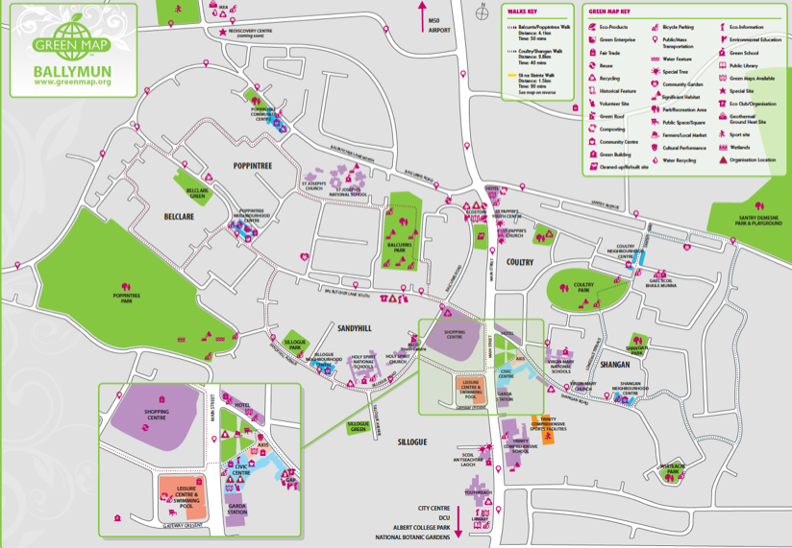

Fig. 2 Green map of Ballymun indicating significant habitats, trees and community gardens

3 Specialist surveys were carried out to record bat activity near a church and provide a biodiversity baseline and management guidelines for Poppintree Park (Scott Cawley, 2011 and 2012). The bat survey (Scott Cawley, 2011) revealed the presence of two bat species (Common Pipistrelle and Leisler’s bat) feeding and commuting in the vicinity of the St. Joseph’s Church and presbytery. The biodiversity baseline study of Poppintree Park produced a habitat map, comprehensive lists of plants and mosses in various habitats, information on the status of birds and recommendations for management to benefit biodiversity. Following scrutiny of these recommendations by park staff, a list of twenty priority actions was drawn up for implementation within the park.

4 The Parks Stewardship Development Programme was produced by GAP and piloted in Ballymun. The objective is to engage local young people in supporting the long-term care, ownership and protection of local parks. The ten week programme, focused on some or all of these activities:

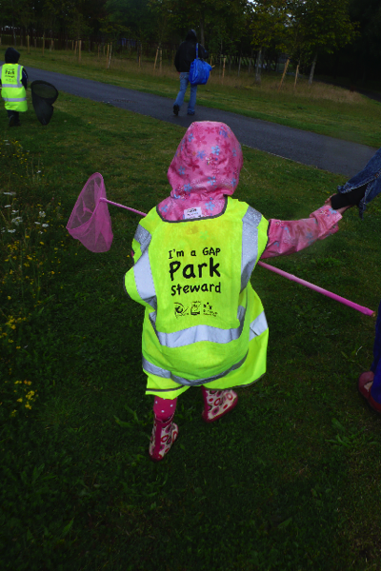
- Nature Trails and biodiversity studies
- Litter picks
- Bulb & tree planting activities
- Art in the park
- Trips to local community gardens and public parks outside of Ballymun

Fig. 3 A young park steward

Since 2011, eleven programmes have been run in eleven schools involving c. two hundred and seventy five students between nine and ten. Participating parks were Coultry, Poppintree and Balcurris.

Independently of this programme a local resident set up a facebook page focusing on the newly development Poppintree Park. This page

https://www.facebook.com/PoppintreePark?fref=ts
contains photographs and news highlighting seasonal changes in the park and the condition of birdlife in the ponds particularly the swans.

5 Ballymun Tidy Towns Group was set up and actively managed by BRL and Gap in co-operation with the community. Having won the Dublin award for biodiversity “Notice Nature” in the previous three years in 2013 Ballymun won the national award for biodiversity in the Tidy Towns competition. Details of all the awards won by Ballymun are in Appendix 1.

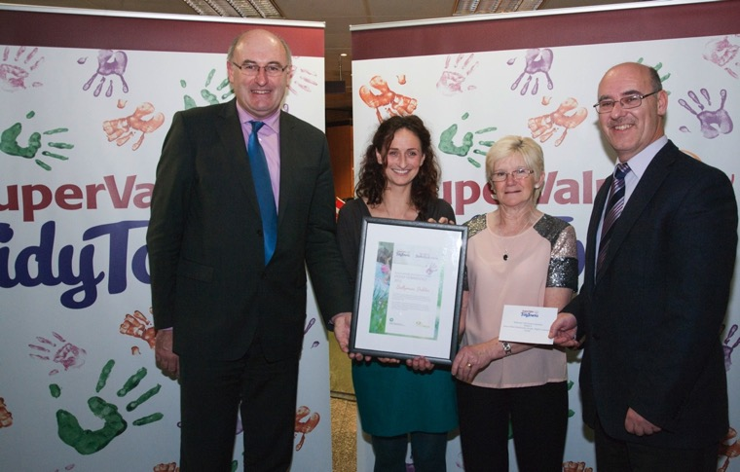

Fig. 4 Representatives from Ballymun being presented with the national award for biodiversity in the 2013 Tidy Towns competition by the Minister for the Environment, Community and Local Government

6 Community Gardens were set up at two locations, Muck and Magic and Virgin Mary Community Garden with the assistance of GAP. Many community-based groups are involved in these gardens. The Ballymun Garden Club is directly involved in managing the “Muck and Magic” Community Garden.

7 Wildflower meadows (Fig. 5) were developed at large publicly owned sites awaiting redevelopment. These proved very attractive to residents.

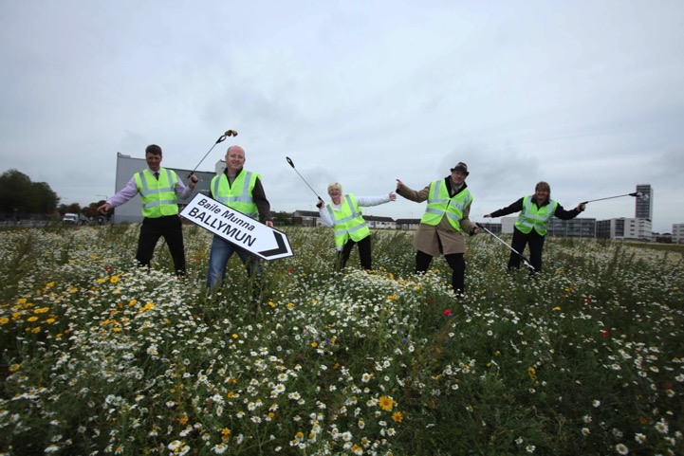

Fig. 5 Members of Ballymun Tidy Towns group celebrating
winning the Dublin award for biodiversity in the Tidy Towns competition 2011 in a newly established wildflower meadow

8 The long standing Fas supported community employment scheme, the Poppintree Environmental Project is involved in managing a garden in senior citizens complex, a community garden, training and environmental awareness raising.

1.5 Policy context

Global
Current approaches to biodiversity management emphasise the services provided by biodiversity which are important for urban society and assist in decreasing its ecological footprint. Examples of these are 1) food production from gardens, 2) reduction in noise due to landscaping particularly near busy roads and 3) health benefits. Biodiversity has direct health benefits as the presence of street trees has been found to be associated with a significantly lower prevalence of early childhood asthma, and use of green areas has also been linked to reduced mortality and increase in general health. Biodiversity provides opportunities to learn about ecology and the relationship between local and global sustainability challenges.
From a traditional approach which only looked at rare species and natural areas, current research is examining the links between biodiversity and these types of ecosystem services and how they can be optimised (http://urbesproject.org).
EU
This shift in focus is starting to become obvious within the EU which is promoting a Green Infrastructure approach to management (European Commission, 2013). The development of Green Infrastructure highlights opportunities to support the provision of these ecosystem services in conjunction with developers and communities.

To safeguard the key Green Infrastructure assets legislation is in place within the EU and Ireland. This focuses on protecting important areas and all rare providers of ecosystem services. It is illegal to interfere with almost all mammals, nesting birds, migratory birds and rare plants. Therefore it is prohibited to clear hedgerows between 1st March to 31st August to protect nesting birds.

National Biodiversity Action Plan 2011-2016
While the current biodiversity plan (Department of Arts, Heritage and the Gaeltacht, 2011) also highlights rare types of habitats and species the vision statement refers to ecosystem services.

“That biodiversity and ecosystems in Ireland are conserved and restored, delivering benefits essential for all sectors of society and that Ireland contributes to efforts to halt the loss of biodiversity and the degradation
of ecosystems in the EU and globally.”

Objectives of particular relevance to Ballymun are:
- To share responsibility for biodiversity facilitated by a local BAP
- To support and encourage the volunteer network that carries out biological recording
- To increase awareness and appreciation of biodiversity and ecosystems services
Associated actions and indicators of particular relevance to Ballymun are:
- Production of a map of habitats
- Number of schools in the Green Schools programme

Regional Planning Guidelines 2010-2020
These guidelines (Dublin Regional Authority and Mid-East Regional Authority, 2010) characterise Green Infrastructure as:

- Supporting nationally and regionally unique habitats , biodiversity and fragile ecosystems
- Having important recreation, tourism and culture roles
- Providing or supporting forestry, crop production, agriculture and energy development
- Providing green buffers/green wedges between built up areas
- Improve air quality

The guidelines emphasis the importance of Green Infrastructure to recreation. On the map of GI assets in the Regional Planning Guidelines (Fig. 6), Ballymun is shown adjacent to a green corridor formed by the Santry River .

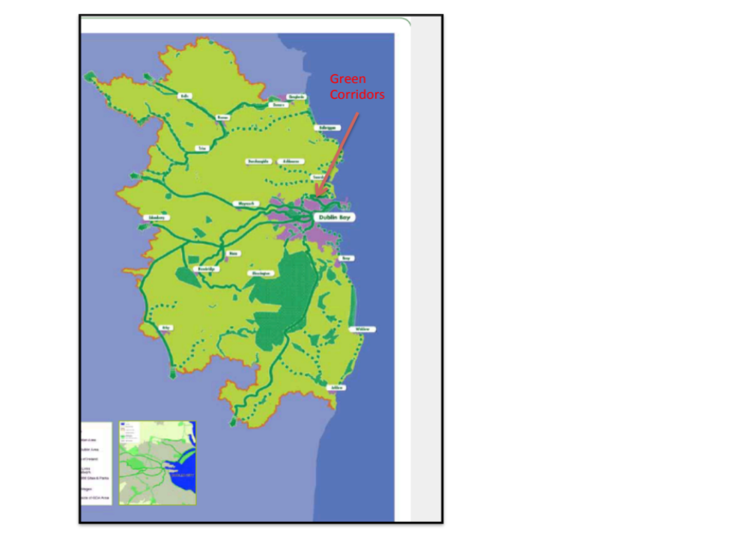

Fig. 6 Green Infrastructure of Greater Dublin Area (Figure 17 Dublin Regional Authority and Mid-east Authority, 2010) showing proposed green corridor in vicinity of Ballymun

The strategic policy objective for Green Infrastructure is:

GIP6
To ensure the protection, enhancement and maintenance of the natural environment and recognise the health benefits as well as the economic, social, environmental and physical value of green spaces through the development of and integration of Green Infrastructure (GI) planning and development in the planning process.

It is also recommended that local authorities prepare a Green Infrastructure strategy in association with statutory plans.

Fingal Development Plan 2011-2017
Fingal’s Development Plan (Fingal County Council 2011) lists Green Infrastructure assets as 1) park developed in Santry Demesne and 2) the course of the Santry River (Fig. 7). The Santry River which feeds the lakes in Santry Park, flows through Sillogue Golf course (Fig. 8). It is culverted under the M50 but emerges for c 100m, immediately southwest of the roundabout, as shown on Fig. 7.

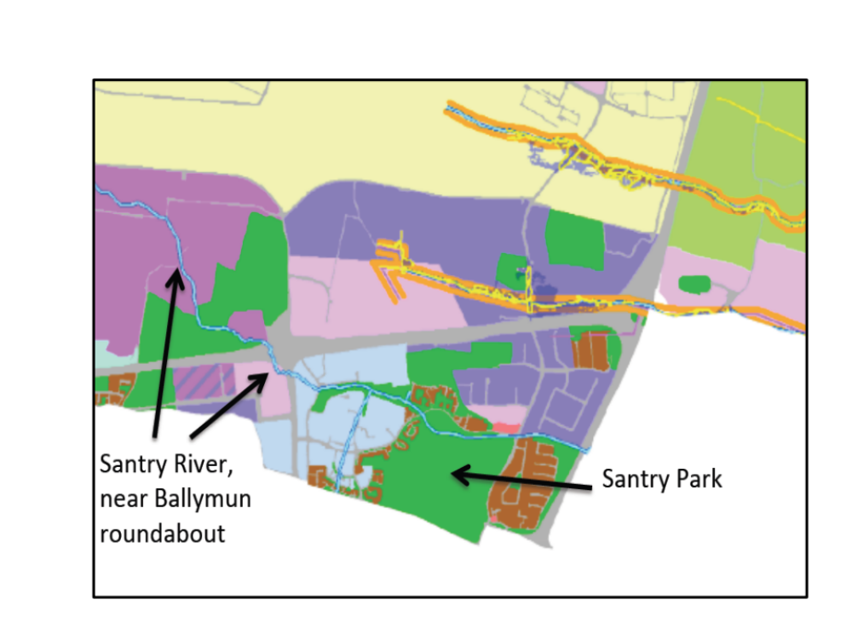

Fig. 7 Green Infrastructure Assets (Fingal Development Plan 2011-2017

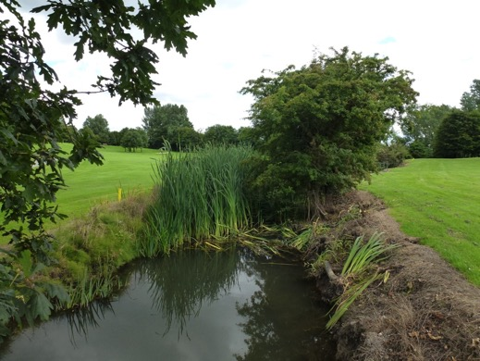
Fig. 8 Santry River in Sillogue golf course

Dublin City Development Plan 2011-2017

The strategy underpinning the Development Plan (Dublin City Council, 2011) comprises three strands

- Compact green well connected
- Smart city
- Neighbourhoods

These strands also reflect concern with climate change, connectivity, public transport, good streets and public realm. Details of the specific policies and objectives relevant to biodiversity, ecosystem services and Green Infrastructure are in Appendix 2.

They require that building design reflects sustainability principles including SUDS (SCO19, S151); that streets, public spaces contribute to greening (SC 24) and street trees are managed appropriately (GCO12). Policies relate to the provision of allotments/community gardens (GC16) and biodiversity enhancement works including the development of new habitats (GC3).

Benefits to biodiversity should also be associated with the implementation of the strategic green transport network (Fig. 9) through Ballymun (GC1 and GC4) and along waterways such as the Santry River (GC9).

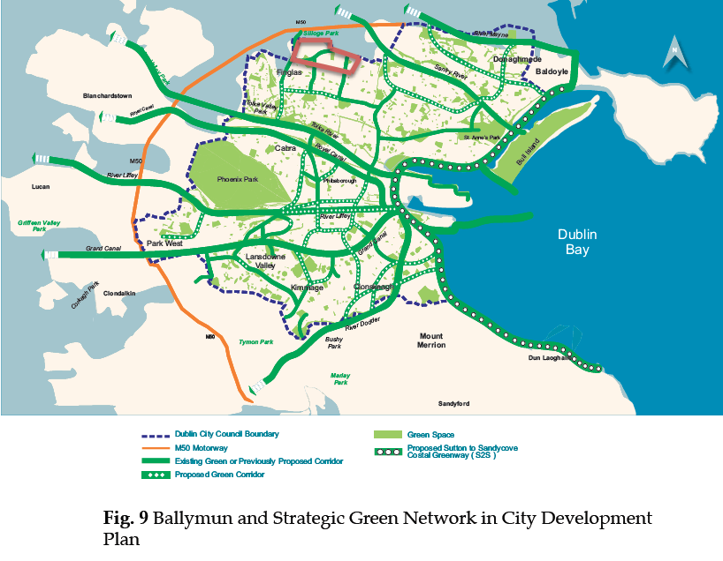

These green routes should connect green areas (GC9), such as Poppintree Park and could be associated with tree planting (GCO14). As the plan incorporates objectives in the City Biodiversity Plan (GC29), it supports the protection of key habitats and species identified in this plan (GCO27 and
GC30) and delivery of environmental education programmes on greening (GCO31) targeted at young children.

Dublin City Biodiversity Action Plan 2008-2012
Priority habitats and species identified in this plan (being revised) were birds, hedgerows and wetlands. Priorities were to manage these features, some of which are present in Ballymun, obtain information about them and raise awareness of their value.

.

2 Evaluation methodology

2.1 Introduction

Work on the evaluation took place between 2012 and 2014 and involved desk research, consultations and fieldwork (mainly in spring and summer 2013).

2.2 Desk research

Desk research involved an inspection of relevant plans, policy documents and biodiversity surveys which had taken place in Ballymun and environs since 2008.

2.3 Consultations

Following consultations with BRL a list was drawn up of potential consultees (Appendix 3). Consultation with this group was facilitated by a semi-structured questionnaire which explored opinions of current status of biodiversity and its future management. Respondents were first asked to identify important features of biodiversity followed by their opinion of whether this represented an improvement (over an unspecified time period) A question on the reasons for change included a set of prompts. The questionnaire covered opinions of the future and indirectly their role as stakeholders. Space and time were provided for the expression of personal opinions.

Mary Tubridy administered the questionnaire during face-to-face interviews with twelve individuals at their location of choice in Ballymun. A further two were self-completed and one interview was conducted over the phone.

To inform the review of biodiversity in Sillogue consultations were held with parks staff managing Sillogue Golf Course on the nature of management practices.

2.4 Fieldwork

Fieldwork focused on the preparation of a habitat map, following Heritage Council specifications (Fossitt, 2000 and Smith et al, 2011) took place in 2012, principally covering the area mapped in 2008. Poppintree Park was not surveyed as this area was recently mapped by Scott Cawley. Additional areas mapped in 2013 were Sillogue Golf Course and the field containing allotments at Meakstown.

While carrying out habitat mapping photographs were taken, lists were compiled of important species of flora and notes were also made of any signs of large mammal activity (badgers and otter).

Habitats were mapped by direct field inspection by Mary Tubridy, assisted by aerial photography. Fieldwork focused on identifying the location and nature of habitats other than those characterized as BL3 (buildings and built surfaces).

In contrast to 2008, where areas in the process of being built upon were mapped as a sub type of BL3, in 2013 all areas covered in buildings were mapped as BL3. Neither was any distinction made between built up areas (BL3) with different size gardens.

The Fossitt habitat category hedgerows WL1 was only applied to field boundaries, almost always >150 years old with vegetation which is typical of woodlands with trees, shrubs and shade loving herbs and which were established on raised banks formed from excavated soil. Therefore newly planted linear areas, locally identified as native hedgerows were categorized as WS1, semi-natural shrubbery.

The final habitat map produced in 2013 was assembled by combining the results of the field survey in 2013 and the habitat data from Poppintree Park survey. See Appendix 4 to examine habitat map of Poppintree area.

A newt survey was carried out in May 2013 in Poppintree following NRA guidelines (NRA, 2006). It commenced after dusk and involved direct inspection of the margins of all ponds using a strong torch to determine any signs of activity such as the presence of newts or newt eggs on suitable vegetation

Tom Cooney who surveyed birds in Ballymun in 2008 carried out a breeding bird survey in Poppintree in July 2013. Fieldwork took place later than planned due to difficulties in accessing maps. All areas in the park were surveyed by walking slowly through all suitable nesting habitats. This was then followed up by observations made over 15-20 minutes in each suitable habitat. In addition, repeat visits to the park over several dates provided a greater chance for scarce/secretive species to be recorded.

The location of all bird species seen and heard were recorded onto field maps using standard BTO (British Trust for Ornithology) recording codes. These maps were later used to establish which species nested in the park in 2013. Survey work took place during good conditions on all dates, times and weather conditions listed below.

July 19th 06:15 - 09:00, 18ºC, SW F2

July 22nd 05:45 - 08:30, 16ºC, SE F1

July 26th 06:00 - 08:30, 15ºC, SW F2

July 29th 09:00 – 11:30, 18ºC, SW F2

Binoculars used: Carl Zeiss 8x42 T*FL

2.5 Constraints

If more time and resources were available the questionnaire survey could have been extended within Ballymun to provide a more representative sample of the population. The breeding bird survey was limited by the time of the year. Converting field survey maps to breeding territories can be subjective and is dependent to a considerable degree on observer experience. In addition, it is worth noting that due to the lateness of this survey in the breeding season, many nesting birds had already dispersed from natal areas and it is therefore not possible to state with confidence whether some species nested within the park. For this reason, several species could only be recorded as ‘probable/possible’ nesters.

Difficulties arose when combining habitat mapping from two sources in Poppintree as the boundaries of some habitats did not correspond to the boundaries shown on current OS digital data. Amalgamating digital data sets from DCC and Fingal to create a base map proved time consuming as each local authority uses a different reference system.

2.6 Outputs

The principal output of the evaluation is this report. The results of habitat mapping in Ballymun (BRL area), Sillogue and Meakstown are contained in digital files which have been give to Dublin City Council together with the metadata report.

3 Results
3.1 The current status of biodiversity
Habitat mapping has shown significant changes in habitat biodiversity since 2007 (Table 2).

Table 2 Changes in habitat area in Ballymun (BRL area) between 2007 and 2012

Habitat Type | Area (ha)  2007 | Area (ha)  2013 | Change since 2008
GA2 Amenity Grassland | 47.31 | 35.27 | -25
GS2 Dry meadows and grassy verges | 6.68 | 17.51 | +162
ED3 Recolonising bare ground | 2.04 | 1.79 | -12
WS3 Ornamental non native shrubs | 1.37 | 1.23 | -10
WD5 Trees and parkland | 0.37 | 1.34 | -262
WS2 Immature trees |  | 0.05
WD1 (Mixed) broadleaved woodland | 1.82 | 0.94 | -48
ED2 Spoil and bare ground | 0.91 | 0.69 | -24
WS1 Native scrub | 0.17 | 0.56 | +229
ED1 Exposed sand gravel or till |  | 1.04
BC2 Horticultural land | 0.02 | 0.19 | +850
WD3 (Mixed) conifer woodland |  | 0.34
GS4 Wet grassland | .61 | 0.55 | -8
FL8 Artificial lakes and ponds |  | 0.47 | Increase from 0
GM1 Marsh |  | 0.11 | Increase from 0

Habitats of biodiversity interest are highlighted in red in this table.

Habitat diversity and the area of the valuable habitats have increased significantly. Habitat diversity increased within Ballymun from ten habitats in 2007 to fifteen in 2013. The new habitats of particular interest were artificial lakes and ponds (FL8), marsh (GM1) established in Poppintree. The other new habitats; exposed sand and gravel (ED1) and two types of woodland (in Poppintree) are of lesser importance and probably reflect difference in interpretation between surveyors when identifying woodland habitat types in Poppintree.

Fieldwork north of the M50 added two more habitats to the locality (not included in the list for Ballymun (BRL area). These are, “drainage ditches” FW4 in Meakstown field and FW2 (Lowland river) or the Santry River (Fig. 10). The Santry River flows from north to south in the golf course before crossing the M50. A short stretch of the river c. 75 m then emerges in a field immediately southwest of the M50 roundabout before entering another culvert.

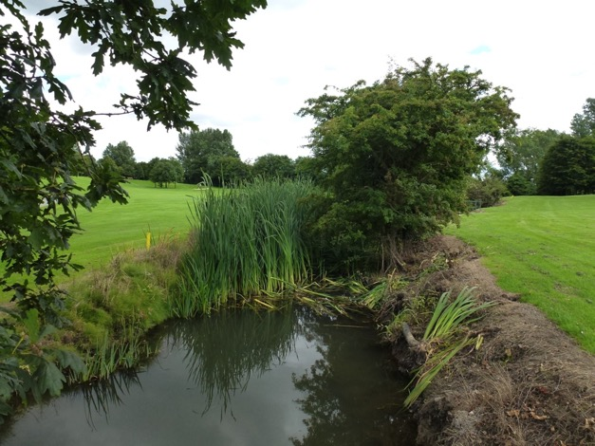

Fig. 10 Santry River in the golf course

Appendix 5 contains a review of biodiversity in the golf course.

The cover of the valuable habitat “dry meadows and grassy verges” (GS2) has increased by 162% largely due to the establishment of wildflower meadows in land awaiting redevelopment.

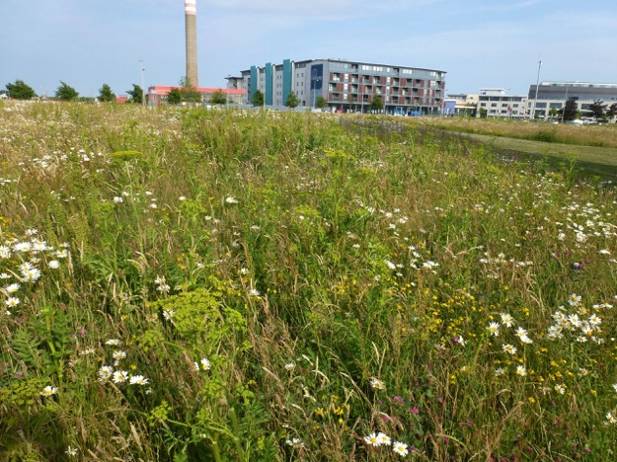
Fig. 11 Planted wildflower meadow on Main Street

This habitat features a greater diversity of grass and forb species compared to the traditional lawn grassland “amenity grassland” (GA2) shown on Fig. 12.

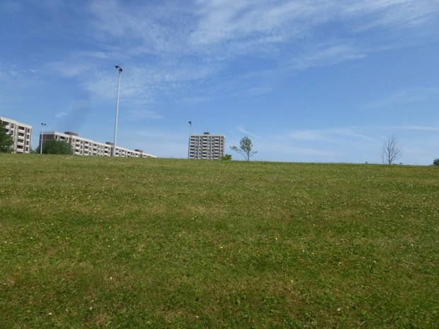
Fig. 12 Original amenity grassland in Ballymun

Because the grass in a wildflower meadow is not cut until late in the season, invertebrates, which provide food for birds, benefit from flowers, seeds and tall stems.

The cover of native shrubbery has increased significantly as the linear hedgerow type habitats in local schools has matured and expanded.

Original hedgerows (Fig. 13) are still present between Ballymun and the M50.

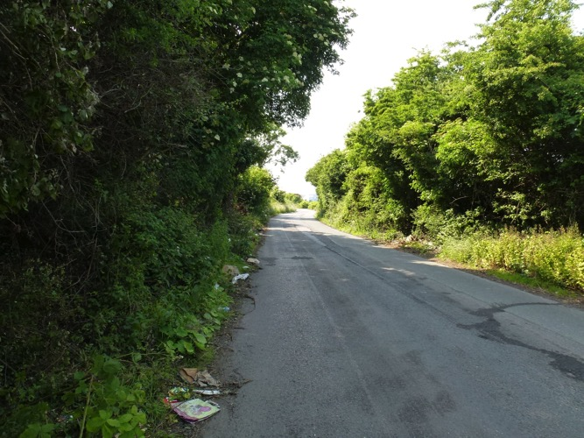
Fig. 13 Hedgerows (WL1) between Ballymun and the M50, a rare habitat within Dublin City

Important new habitats within Ballymun are the wetland types “artificial lakes and ponds” (FL8) and “marsh” (GM1) associated with new ponds in Poppintree

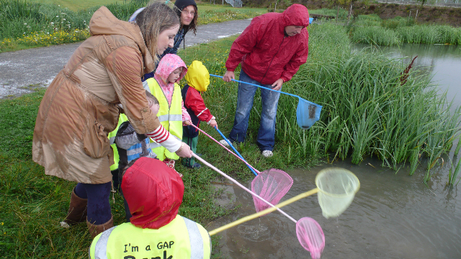

Fig. 14 Pond dipping in Poppintree as part of GAP’s Park Stewardship Project

As the location of these wetland types and “wet grassland” grade into each other they comprise “ecotones” which add to the value of individual habitats. The development of these wetland habitats now means that typical wetland flora and fauna are commonly present in Ballymun (Fig.14). The diversity of invertebrates typically associated with wetland should attract feeding bats. Bats have been recorded feeding in other areas in Ballymun and it is likely that bats use Poppintree.

However survey work early in the year failed to reveal any newts in the ponds. There has been a significant decline in the area of amenity grassland and trees and parklands since 2007 possibly due to the redevelopment of Poppintree. Habitats in Ballymun, highlighted in the BAP, hedgerows and mature trees are still present.

Plant biodiversity has improved through management and environmental education initiatives. Gardens established in new houses since 2008 are all planted with biodiversity friendly species. The presence of a marsh orchid in the grassland associated with a school (Fig. 15) is directly associated with the school’s policy of late mowing to encourage wildlife.
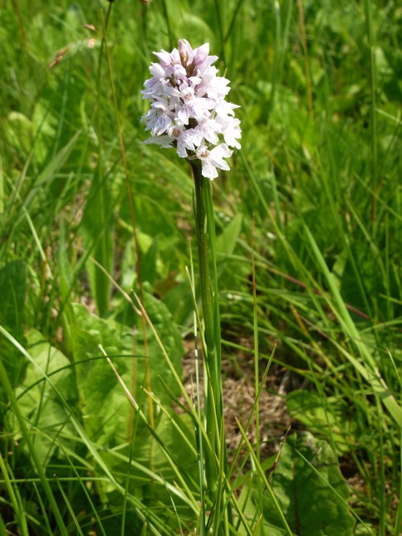
Fig. 15 March orchid in grassland in school grounds between Holy Spirit School and Balbutcher Lane

More information is now available on species biodiversity and there are indications that this is increasing as new habitats mature. A bird survey carried out in 2013 revealed thirty bird species in Poppintree, two more than that recorded in 2012. The extra birds are the amber listed species, tufted duck and great black-backed gull. Tufted duck bred in the pond. There are now between seven to sixteen species of breeding birds in Poppintree mainly around ponds. An account of all birds recorded in Poppintree is in Appendix 6. Table 3 contains a list of birds recorded in summer 2013.

Table 3. List of all 30 bird species recorded at Poppintree Park, July 2013.
* confirmed nesting
⁺ probable/possible nesting within park

Common Name | Scientific Name | Conservation Status
Little Grebe* | Tachybaptus ruficollis | Amber
Grey Heron | Ardea cinerea
Mute Swan* | Cygnus olor | Amber
Mallard* | Anas platyrhynchos
Tufted Duck* | Aythya fuligula | Amber
Moorhen* | Gallinula chloropus
Coot* | Fulica atra | Amber
Great Black-backed Gull | Larus marinus | Amber
Herring Gull | Larus argentatus | RED
Lesser Black-backed Gull | Larus fuscus | Amber
Black-headed Gull | Chroicocephalus ridibundus | RE
Wood Pigeon⁺ | Columba palumbus
Feral Pigeon | Columba livia
Common Swift | Apus apus | Amber
Barn Swallow | Hirundo rustica | Amber
House Martin | Delichon urbicum | Amber
Pied Wagtail⁺ | Motacilla alba yarrellii
Wren⁺ | Troglodytes troglodytes
Dunnock⁺ | Prunella modularis
Blackbird⁺ | Turdus merula
Robin⁺ | Erithacus rubecula
Blue Tit⁺ | Cyanistes caeruleus
Magpie* | Pica pica
Jackdaw | Corvus monedula
Rook | Corvus frugilegus
Hooded Crow⁺ | Corvus cornix
Raven | Corvus corax
Starling⁺ | Sturnus vulgaris | Amber
House Sparrow | Passer domesticus | Amber
Greenfinch | Chloris chloris
Conservation status (Amber and Red) is only highlighted for vulnerable species only.

Other locally rare animal species now known to occur in Ballymun and vicinity include the ruddy darter damselfly (Fig.16), abundantly in drainage ditches near Meakstown allotments in 2013; buzzard, nesting in tall trees in Sillogue Golf Course; siskin feeding on newly planted alder trees growing in streets (Ray Leahy, resident, pers.comm.) and hedgehog (Dorothea Burger, landscape architect, pers.comm.).

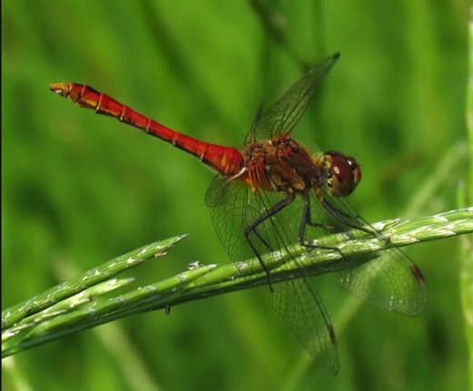

Fig. 16 Ruddy darter damselfly

Education on biodiversity has been provided to many members of various sectors of society including almost all primary schoolchildren, youth groups, many new householders, members of the public interested in gardening and members of unemployed and excluded groups. Groups from St Michael’s House spend time in Muck and Magic community garden set up by Ballymun Garden Club. Significant numbers of households have been involved in garden action teams (75 teams).

With the assistance of Gap, various community based groups have taken responsibility for plots in the Virgin Mary Community Garden.

Information has also been provided to the general population through events, Tidy Towns activities and newsletters. The Tidy Towns group which is assisted by GAP and BRL has put a particular focus on biodiversity culminating in winning the national Notice Nature Award in 2013 (Appendix 1).

As a result of the support provided by GAP, all primary schools in Ballymun have wildlife gardens and some have extensive lengths of hedgerow type habitat.

3.2 Community awareness of biodiversity

The results of the focused consultation provide an insight on local perceptions of the current status of biodiversity. When asked “What are the most important areas for biodiversity in Ballymun? almost all respondents referred to managed nature (89%) in contrast to unmanaged nature (11%). Specific areas mentioned in the former category (all responses = 28) are shown in Fig. 17

Fig. 17 Areas important for biodiversity

The survey also revealed a general awareness of different types of biodiversity (Fig. 18)

Fig. 18 Species and groups in response to question “ What are the most important species?

.

The answer to a question on whether the area has become more or less interesting for biodiversity was in the affirmative from the majority of respondents (Fig. 19).

Fig. 19 Response to question “Has the area got more or less interesting?

One respondent considered that there was more space for nature before regeneration as the area had more trees and shrubberies including a natural vs “artificial” wetland in Poppintree Park. Another consultee alluded to the value of Santry Demesne as a wild playground.

3.3 Gardening, community gardening and allotments

Gardening has been the key to the involvement of the general public, youth and community groups. This is further supported by the success of the gardens competition, run by BRL in association with the Botanic Gardens and the provision of allotments in Meakstown by DCC/BRL. It can be assumed that gardeners from Ballymun who have graduated through the Garden Action Teams have probably brought their awareness of biodiversity to the management of their allotment.

The development of community gardens and allotments has improved biodiversity in their locations, particularly when features such as composting facilities, wood piles, shrubberies and wetlands are added.

Community gardens and allotments have allowed for more intensive usage of public green spaces. The Parks Stewardship Programme engages school children with their local park, thus encouraging a sense of ownership while providing environmental education in the outdoors. Involvement included tree planting with adult volunteers in Poppintree.

The work of GAP has been crucial in enhancing awareness of biodiversity among the community. Community efforts have been successful because individuals with expertise and experience support them.

The project has led to the production of resource materials which can be used by any group interested in using the local parks for environmental education. These include the Winter Nature Trail in Balcurris and the Native Tree trail for Poppintree Park. Electronic dissemination supports easy access to these materials by schools and the public.

3.4 Implementation of statutory policy objectives

Biodiversity related actions in Ballymun have supported the achievement of objectives in the National Biodiversity Action Plan “ Production of a map of habitats” and “Schools involvement in greening programmes” Works are more relevant to the achievement of objectives in Dublin City Development Plan in relation to the development of new habitats (GC3), the protection of key habitats and species identified in the City BAP (GCO27) and environmental education targeted at young children (GCO31).

3.5 Weaknesses/threats to biodiversity management

Anti-social activity, expressed through dumping of waste and disturbance of wildlife is a major threat to biodiversity as it prevents the public enjoying its value as an amenity. Due to changes in waste management there is an increased risk of the public dumping household waste in parks and biodiversity rich areas. This issue has another indirect impact on biodiversity as resources which could be allocated to biodiversity management by parks are directed at dealing with anti-social activity. Anti-social activity also deters access to interesting semi-natural habitats such as derelict fields and hedgerows near the M50

As remaining hedgerows in Ballymun and the visible section of the river are not identified for special protection in statutory plans, these features are vulnerable to insensitive development. Removal of these important biodiversity features without mitigation is a threat to biodiversity.

Inappropriate management in public green spaces, threatens biodiversity particularly in those areas in parks which are of high biodiversity quality. Pollution of ponds in Poppintree limits their potential to support freshwater biodiversity.

A lack of information on the value of the current range of Irish wildflower mixes means that their use in landscaping is problematic. Similarly lack of information on the appropriate management of planted wild flower meadows threatens their long term usefulness for biodiversity.

Lack of awareness of the value of urban biodiversity by the national authorities, with the exception of National Botanic Gardens means that little support is available for urban biodiversity projects. Resources for management are almost solely available from local sources. The winding down of BRL could threaten biodiversity management in Ballymun if supports are no longer available for the community and school based initiatives which have supported management and enhancement. Thus recent cut backs in public spending which have affected support for all public sector projects might also threaten biodiversity if they result in reduced potential for funding of biodiversity management in Ballymun.

3.6 Trends

Comparison between 2007 and 2013, based on the types of habitat and the area of GS2 suggests that the quality of biodiversity is improving overall. If biodiversity management continues to be supported by the authorities, this upward trend is likely to be maintained.

As planted areas (trees, gardens, wildlife gardens, community gardens, planted hedgerows) mature, they will offer more habitat for wildlife i.e. invertebrates and their prey. Thus the population of birds will increase, and suitable nesting habitat, in relatively undisturbed areas, may become available. Bird boxes may be used for nesting birds. With appropriate management wildflower meadows can continue to support the flowering annuals which attract wildlife.

Species diversity is likely to increase in Poppintree as birds will facilitate the dispersal of suitable species from nearby wetlands to Poppintree.
Street trees planted in lines will start to resemble the habitat, tree lines (WL2) and act as wildlife corridors supporting commuting birds and bats. The population of siskin will probably rise as alder plants mature and provide more winter food for this species.

Biodiversity will increase significantly when management works to enhance biodiversity, recommended for parks (in the first BAP and in Scott Cawley,2012) are fully implemented.

4 Conclusions

4.1 Impact of the Biodiversity Action Plan

While some actions were carried out directly as suggested in the BAP they were generally modified in response to local knowledge and experience to achieve the same or better result. For example the biodiversity category in the Garden competition was incorporated in the general garden evaluation. Bioblitz Ballymun style did not feature the recruitment of many outside recorders but a walk in a park in the company of a wildlife expert.

Several actions listed in the plan were not attempted for very valid reasons. Technically difficult actions were avoided (web cam for birds). A working relationship on environmental education was not established with the Comprehensive. In contrast to newly developed areas, where biodiversity was given priority, there was less evidence for the adoption of wildlife friendly landscape practices in existing landscaped spaces i.e. older public green spaces. except in the grounds of schools. The lack of availability of relevant biodiversity expertise and lack of interest by the authorities meant that no monitoring of biodiversity was attempted.

The assessment of its achievements since 2008 confirmed that the BAP succeeded in defining a work programme for GAP, the primary implementation body and its newly recruited environmentalist. It has also shown that over the timescale of the plan significant improvements occurred to local biodiversity and that these occurred through a partnership process with the local community. The implementation of the BAP was the catalyst for this improvement. The implementation group allowed for the exchange of knowledge, experience and advice on local biodiversity actions contained in the BAP. The members of this group were actively involved in a range of initiatives in the community and were regularly discussing their impact at the implementation group meetings. This learning environment re affirmed the relevance of particular work, clarified priorities and helped to reveal opportunities for new initiatives. Discussion on indicators led to an agreement on three possible indicators, bird species, butterflies and flora in swales (which colonised naturally).

Projects which arose from this partnership and contributed significantly to improvements included:
Wildflower meadows
Parks Stewardship programme
Community Gardens
Tidy Towns

The consultation which was carried out seems to confirm the importance of this group. While only a small number of responses were obtained (13) to the question “ Rank the importance of the following: money, human resources/commitment, partnership, policy, research and anything else to the promotion of biodiversity” it is clear that networking by committed people working in partnership was most significant (Fig. 20). Policy and money were not rated as highly.

Fig. 20 Question on the importance of various factors to the promotion of biodiversity

4.2 Opportunities for Ballymun

The answer to the question “Looking forward what would you like to see in the future for biodiversity in Ballymun.?” provided a range of suggestions the majority of which related to either parks or the community (Fig. 21). Answers confirm their awareness of the types of initiatives which were carried out and their targets.

Fig. 21 Initiatives suggested by consultees

To safeguard the achievements of the last five years and maintain this momentum the following conditions must be met:

1 Implementation group

An implementation group has to remain in place. This could have greater representation of community interests and possibly stronger links with Poppintree Environmental Project and the Axis Arts Centre. It could take on the added task of promoting Ballymun as a centre of excellence for urban biodiversity. BRL acted as coordinator of the group. A new coordinator needs to be appointed by DCC.

2 Services of GAP

As GAP has been essential to the delivery of improvements to biodiversity in gardens, school gardens, community gardens and delivery of environmental education programmes within and outside schools their services should be retained.

3 Work programme

The six themes contained in the first BAP can be reduced to four.

- Increase awareness and enjoyment
- Carefully manage areas of high value
- Monitor improvement
- Disseminate results

1 Increase awareness and support

Actions under Theme 1 should be the principal responsibility of GAP and DCC and involve a continuation of their previous role which can be summarized as:

- Liaison between community and DCC on greening issues
- Supporting role to Tidy Towns and community gardens (Virgin Mary Garden, Muck and Magic Garden/Ballymun Garden Club)
- Supporting community based initiatives in schools, garden action teams, community support projects and youth groups
- Organising environmental education events and activities with groups in local parks.

From 2013 measures should be put in place to enable these community groups become more independent through assistance with the establishment of effective organizational structures and training. Community development specialists in DCC should be asked to assist with this development.

Parks staff could be more involved in environmental education programmes such as the Parks Stewardship Programme as a form of “soft education” on biodiversity. The stewardship approach could be used to inform environmental education programme for golfers at Sillogue Golf Club. Working with the park staff, liaison could be established with environmental volunteering groups to support implementation of biodiversity actions in parks.

If support is available (intern with computer skills) GAP should establish a
Ballymun Biodiversity Data Centre or Facebook page. This would maintain a record of birds, plants etc. in Ballymun. The web pages could contain resource materials, the habitat map, reports, suggestions for student projects, including more challenging projects in 1st BAP i.e. web cam for birds. Local recorders could send in a photo of species for identification to be transferred to a voluntary naturalist for verification.

2 Carefully manage areas of high biodiversity value

The involvement of a BRL planner in the implementation group protected areas of high value as they were able to draw developer’s attention to valuable features in pre-planning etc. This sector should continue to be represented in the implementation group by a planning officer from DCC.

An opportunity should be taken to develop a Green Infrastructure Strategy in association with a Local Area Plan for Ballymun, as required by the Regional Planning Guidelines. Recently produced habitat mapping would support this strategy and could be extended to cover all undeveloped areas. A GI strategy would highlight areas of high value to the public, discuss the broad range of ecosystem services and functions which biodiversity provides and consider how they can be maintained and improved having regard to the achievements related to the BAP and Ballymun’s location on the edge of the city. A GI strategy/Local Area Plan would recognize the value of the recently established wildflower meadows in land awaiting redevelopment. It would support the objectives related to the implementation of Green Routes which are part of the city network (Fig.9). Considerable resources have been dedicated to street tree planting. Walking routes (Sli na Slainte) have been developed to link green areas. Ballymun has particular potential to identify routes linking the city to the wider countryside, possibly involving river courses as indicated by the Regional Planning Guidelines. A plan for Strategic Green Routes in Ballymun would draw attention to the original tree planting project, offer an opportunity to assess these trees and allow for a strategic approach to planting along Green Routes, walking and cycling routes linking green areas. A GI strategy could also examine the feasibility of developing a wildlife refuge (area of biodiversity value which is not used as an amenity) within Ballymun.

3 Monitor improvements in biodiversity

This review used habitat mapping as an indicator of biodiversity quality, principally because baseline information was available (for Ballymun and the city) and habitats are widely accepted as a means of describing biodiversity. To develop other locally based indicators the implementation group could consider developing simple reliable procedures for measuring their preferred indicators, birds, butterflies, and flora in swales.

Bird biodiversity could be measured through monitoring the impact of bird boxes. This could be done (possible student project/intern) each year. Monitoring does not require great technical skill. Two signs of usage give an indication (but not proof) that boxes were used in the nesting season. These include (i) white bird droppings just below the entrance holes suggesting birds have been entering the nest box and (ii) signs that birds have pecked at the edges of the entrance holes to widen them as part of the nest building ritual i.e. the edges of the entrance holes are not smooth but have obviously been pecked at. Signs of one or both suggest the success of the scheme. To assist survey each box should be numbered and each one should be surveyed during the nesting season. It should be noted that birds can also use nest boxes for roosting in winter. They provide a safe and dry environment for small birds e.g. blue tits.

Butterfly monitoring could be linked to the scheme run by the National Biodiversity Data Centre, which supports volunteer butterfly recorders throughout Ireland.

Encouragement should be given to research projects which general involve the collection of much baseline data. Potential projects and specialist areas are

Water quality in Poppintree Park and possible options for treatment
(M.Sc in water quality control, Sligo, Dundalk IT or UCD)

Biodiversity awareness in Ballymun compared to other areas in the city (PhD in environmental education, Depts of Education in universities and training colleges).

Evaluation of citizen science (involvement in biodiversity) Potential for funding from EPA research funds 2014 (Maryann Harris, pers.comm.)

Characterisation of corridors for invertebrates, birds or bats
(Undergraduate theses Environmental Science or Zoology)

Tree species and their associated invertebrate biodiversity
(Undergraduate theses in Zoology, UCD/TCD)

Management of wildflower meadows: examining various management practices
(MSc. Environmental Science, Natural Resources Management)

4 Disseminate results

While efforts must continue to communicate news and results of greening initiatives within Ballymun, there is a particular need to communicate with a wider community of individuals involved in greening initiatives in urban areas. In the absence of the regular BRL newsletter it will be necessary to find another local medium possibly a free community broadsheet and 2) a web based medium, perhaps hosted by GAP? which can be used to communicate news of events etc. Networking outside Ballymun on urban biodiversity initiatives by individuals and organisations supported by GAP/DCC should be encouraged.

Similarly applying for grants and entering competitions enhances contacts and awareness.
The new implementation group, in partnership with the Council should organize a national conference, similar to that organized by Fingal County Council in 2008 on Green Infrastructure to promote urban biodiversity. This type of event would disseminate the results of the environmental education programme in Ballymun to the wider community. It would also show the evidence for improvement which should lead to greater awareness of the potential for success among the authorities.

4.3 Lessons from the evaluation

Lessons are:
- Implementation of the plan was successful as it had a time limited set of actions and it was developed following field studies by specialist ecologists/ environmentalists.
- The most successful actions promoted the involvement of the community. These included activities in schools and public parks, actions related to environmental education and gardening related activities including the development of valuable habitats.
- Implementation would not have been successful without a framework which had the mandate and resources (personnel and capital budget) to support the delivery of the required actions.
- The presence of a facilitator/co-ordinator working with a spatially focused implementation group was essential. This group was representative of the authorities and delivery bodies. Its regular meetings provided a forum for evaluation, discussion and support for biodiversity related activities.

General recommendations arising from the evaluation are that:

- A minimum budgetary allocation of at least €1/ per person/year is needed to provide a community focused service which enhances local biodiversity in the city.
- Biodiversity Action Plans or similar should be embedded in effective /possibly statutory frameworks and engage a wide range of sectors.
- All actions should involve a partnership approach between the statutory sector and the community.

References

Ballymun Regeneration Limited (2008) Ballymun Biodiversity Action Plan, Image Project, Ballymun Regeneration Limited.

Department of Arts, Heritage and the Gaeltacht, (2011) Actions for Biodiversity: Ireland’s National Biodiversity Plan 2011-2016, Department of Arts, Heritage and the Gaeltacht.

Dublin City Council (2011), Dublin City Development Plan 2011-2017, Dublin City Council.

Dublin Regional Authority and Mid-East Regional Authority (2010), Regional Planning Guidelines For The Greater Dublin Area 2010-2022.

European Commission (2013) Communication from the Commission to the European Parliament, the Council, the European Economic and Social Committee and the Committee of the Regions - Green Infrastructure (GI) Enhancing Europe’s Natural Capital. /* COM/2013/0249 final */ [Accessed 22 July 2013]

Fingal County Council (2011) Fingal Development Plan 2011-2017, Fingal County Council.

Fossitt J, (2000) A Guide to Habitats in Ireland, Heritage Council, Kilkenny.

NRA (2006) Ecological Surveying Techniques for Protected Flora and Fauna during the Planning of National Road Schemes.

ScottCawley, (2011) Bat Survey for St Joseph’s Church/Termon Court, Unpublished report prepared for Ballymun Regeneration Limited.

Scott Cawley, (2012) (Draft) Poppintree Park Biodiversity Study, Unpublished report prepared for Ballymun Regeneration Limited.

Smith, G O ‘Donoghue, P O Hora, and Delaney, E (2011) Best Practice Guidance for Habitat Survey and Mapping, Heritage Council.

Tzoulas, K & James, P (2009), Making biodiversity measures accessible to non-specialists: an innovative method for rapid assessment of urban biodiversity, Urban Ecosyst (2010) 13:113–127
DOI 10.1007/s11252-009-0107-x

Wyse-Jackson, P (2008), The Greening of Ballymun in McCrann, A., (ed.) Memories Milestones and New Horizons: Reflections on the Regeneration of Ballymun, Blackstaff Press, Belfast.

Appendix 1

Biodiversity awards achieved by Ballymun Tidy Towns Group

2006
- Tidy Towns - Best New Entry

2007
- Tidy Towns - Notice Nature Biodiversity Award - Native hedgerow project (Regional)

2008
- National Green Community Award – The Green Awards
- Tidy Towns - Endeavour Award (Dublin Region)

2009
- National Green Community Award – The Green Awards
- Tidy Towns -Notice Nature Biodiversity Award-Dublin Region

2010
- National Green Community Award – The Green Awards
- Tidy Towns - Notice Nature Biodiversity Award-Dublin Region

2011
- Tidy Towns - Notice Nature Biodiversity Award- Dublin Region

2012
- Tidy Towns - Notice Nature Biodiversity Award - Highly Commended Nationally

2013
- Tidy Towns - Notice Nature Biodiversity Award- National Winner

Appendix 2
Dublin City Development Plan 2011-2017
Policies and Objectives Related to Biodiversity

SCO19
To require that proposals demonstrate that sustainability has been properly considered at the strategic, urban design level of decision-making
so as to improve the level of environmental efficiency achievable in the detailed design of buildings.

SC24
To promote streets and public spaces which contribute towards increased urban greening

S151
To incorporate and promote the use of Sustainable Urban Drainage Systems within City Council Developments and other infrastructural projects as set out in the Greater Dublin Regional Code of Practice for Drainage Works (see also Policy GCO4 and section 16.2.3).

GC1
To progress a strategic network as illustrated in the Strategic
Green Network map (see Figure 10).

GC3
To make provision for habitat creation/maintenance and
facilitate biodiversity by encouraging the development of linear parks, nature trails, wildlife corridors and urban woodlands

GC4
To improve both biodiversity and access connections with the strategic network at the level of local planning. Green corridors will be pivotal in achieving this.
GC7
To co-ordinate between open space, biodiversity and flood management, in progressing a green infrastructure network.

GC8
To develop a network of green corridors through the city, thereby interconnecting key open spaces, and extending out to the wider Dublin region.

GC9
To develop linear parks, particularly along waterways, and to link existing parks and open spaces in order to provide green chains throughout the city. Where lands along waterways are in private ownership it shall be policy, in any development proposal, to secure public access along the waterway

GCO1
To progress the illustrated strategic green infrastructure network and to devise a program of specific works to be implemented within the current development plan timeframe (see Strategic Green Network Map and also City Centre Routes Map, Figures 10 and 11)
GCO2
To achieve the following critical linkages within the lifetime of the development plan;
(including the following)
To improve access to existing natural assets such as parks and waterways through identified green routes.
GCO12
To manage street and roadside trees in an environmentally sensitive and arboriculturally appropriate manner, to be vigilant in ensuring the conservation of all street and roadside trees under its care.
GCO14
To implement a programme for enhanced planting along proposed green routes through existing developed areas. This shall be carried out in accordance with a programme of works to be drawn up on an annual basis, specifying routes involved.

GCO47
To implement the City Parks Habitat Management Plans for St. Anne’s Park, Springdale Linear Park, Le Fanu Park, St. Kevin’s Park, and Bushy Park, and to produce and implement further Park Habitat Management Plans where appropriate

GC15
To continue to manage and protect and/or enhance public open spaces to meet the social, recreational, conservational and ecological needs of the city and to consider the development of appropriate complementary facilities which do not detract from the amenities of spaces

GC16
To support the provision of community gardens/allotments/ local markets/pocket parks, where feasible and in particular as temporary uses on vacant, underutilized or derelict sites in the city.

GC18
To protect the unique natural amenities of all rivers within and forming boundaries to the administrative area of Dublin City Council and to establish River Basin Management Plans, in co-operation with other relevant authorities.

GC19
To protect, maintain, improve and enhance the natural and organic character of the watercourses in the city, and to promote access, walkways and other recreational uses of their associated open space, incorporating flood strategies and subject to a defined strategy of nature conservation in consultation with Inland Fisheries Ireland. The creation and/or enhancement
of riparian buffer zones will be required where possible. It is the policy of Dublin City Council to maintain, improve and enhance the safety of the public in its use and enjoyment of the many public parks, open spaces and linkages within the city. This should apply, for example, to all areas of the
Royal and Grand Canal.

GCO16
To implement a programme for suitable tree planting along centre-road verges where there is already soft landscaping, in particular along national primary routes and major approaches to the city, including innovation corridors.

GCO23
To enhance the amenities of the river valleys of the Santry and Mayne rivers and to protect the drainage and environmental role of the Kilbarrack stream, Grange river and Nanikin river.

GCO19

To provide for allotments and community gardens, where appropriate, as a regular feature of city council parks and public open spaces.

GC25
To protect and enhance biodiversity in the city through the protection of nature conservation sites, maintenance of valuable mitigation habitats, the creation of a cohesive network of green corridors, green infrastructure design and also through the identification of opportunities for new habitats, buffer zones and wildlife corridors. Buffer zone is a protective area between wildlife / habitats & human activity, – traffic noise etc.

GC28
To seek the conservation and management of areas of natural environmental value.

GC29
To conserve priority species, habitats, and natural heritage features identified in the Dublin City Biodiversity Action Plan 2008 – 2012 for priority conservation measure.

GC30
To have regard to the conservation and enhancement of significant non-designated areas of ecological importance in accordance with development standards set out in this plan

GCO27
To support the implementation of the ‘Dublin City Biodiversity Action Plan 2008-2012, including inter alia (a) the conservation of priority species, habitats and natural heritage features, and (b) the protection of designated sites.

GCO31
To involve children and young people in greening initiatives and biodiversity projects, having regard to their need to interact with and be educated by nature.

Appendix 3
Consultees

Dorothea Burger, Landscape Architect, BRL Ltd.
Mick Burke, Parks Department, DCC.
Mary Couch, Manager, Poppintree Environmental Project.
Frank Darcy, Parks Department, DCC.
Maryann Harris, Parks Superintendent, Biodiversity, DCC.
Tom Hassett, Parks Department, DCC.
Matthew Jebb, Director, National Botanic Gardens.
Ray Leahy, Winner Ballymun Best Garden Competition.
Ronnie Mc Connell, Ballymun Garden Club and Muck and Magic Garden.
Andrew Montague, DCC Councilor.
Robert Murphy, SuperValu, Ballymun.
John O’Donoghue, Muck and Magic Community Garden.
Lynn Boylan, Ecologist, Community Programme Co-ordinator, Global Action Plan.
Maire Hurley, Community Gardener, Global Action Plan.
Roger Warburton, Environmental Manager, BRL Ltd.

Appendix 4
Poppintree (west end) Habitat Map 2013

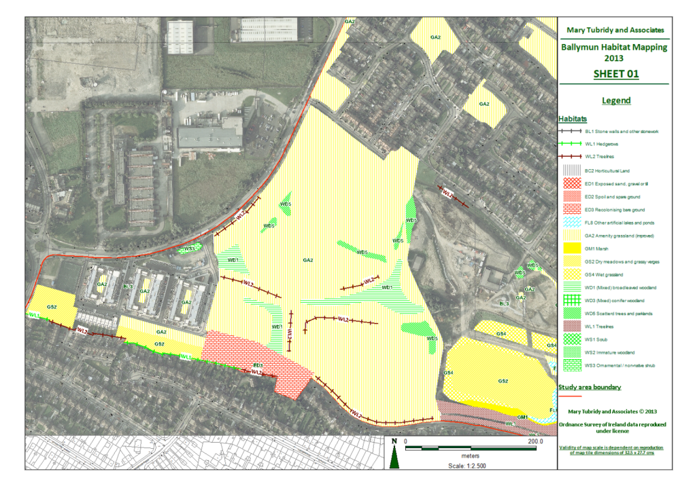

Appendix 5
Sillogue Golf Course: Preliminary review of biodiversity and its potential for improvement

Features of biodiversity importance are (1) the environs of the Santry River where it is surrounded by semi-natural vegetation, (2) (mainly) boundary hedgerows and (3) nesting buzzard in trees near the yard. The course is surrounded by either farmland or undeveloped land. A large artificial wetland (30mX 30m) was found between it and NCT centre (July 2013).
Hedgerows are almost all pre 18th century and those nearer the river and along townland boundaries could be older. Several native tree and shrub species such as elm, blackthorn , hawthorn, bramble, oak, elder, dog rose, ash and gorse are found in the hedgerows. Their associated drains are almost all dry. The river is partly culverted in the course but still has several wetland species including fool’s watercress, watercress, water plantain, figwort, brooklime, angelica, bulrush, and yellow flag and a small area of marginal vegetation dominated by bulrush (planted?). A significant number of mainly broadleaved trees were planted in 1954 and 1995 throughout the course. These form narrow linear woodlands around the margin and copses within the course. They are almost all devoid of a shrub layer. Occasionally a remnant woodland understory is found within them with woodland plants such as primrose, false brome, remote sedge, hard fern and soft shield fern. While the dominant habitat in the course is amenity grassland (GA2) some small areas with uncut grass (GS2 dry meadows and grassy verges) are found. While most of the woodlands were identified as trees and parkland (WD5) some were categorized as (mixed) broadleaved woodland (WD1) as they had a shrub layer. Groundwater is used to water greens. The dense hedgerows provide good feeding and nesting habitat for typical farmland birds. Other species of interest include the butterflies speckled wood, tortoiseshell, numerous rabbits, and a water hen in the Santry.
Water quality in the Santry River is poor principally due to the effects of development upstream.
Management practices in the golf course are principally focused on maximizing the extent of bare open ground to enable golfers retrieve their golf balls. As a result herbicide is used to control vegetation close to drains, shrub vegetation is controlled in almost all woodlands and there is little vegetation surrounding the river in the golf course.
Good quality biodiversity is associated with the location of the golf course surrounded by undeveloped land, the presence of dense hedgerows forming its boundary, some old mature pre 1954 trees and part of the course of the Santry River. The presence of the golf course protects the area from development. The absence of development around it ensures the survival of the boundary hedgerows. Thus the principal objective of management is to retain this use and to ensure that if development occurs the hedgerows will be retained.
To improve the quality of biodiversity the following three actions could be considered:
- Adjustments to weed control practices in order to reduce herbicide usage near drains, river and hedgerows. This process could start by initially recording (litres) volumes of herbicide use /year and gradually attempting to reduce this volume year by year. Spraying practices should be altered to reduce spray volumes near these features.
- Gradual abandonment of the practice of removing all understory vegetation and scrub from under trees and near the river and hedgerows.
- Education of golfers. Golfers should be informed about the importance of wild areas in the course for wildlife to explain why these areas are being preserved and improved.

To implement these guidelines further consultations are needed with course managers to discuss the most suitable areas to slowly introduce these practises.
Other measures which would improve biodiversity include
Establishment of more areas of tall grass (GS2)
Monitoring of the Santry River before and after entering the golf course
Specific improvements to landscaping around the Santry River to improve its value for biodiversity.
Identification of a specific area suitable for dumping organic waste materials
There are numerous certification schemes which assist golf course managers achieve improvements to biodiversity. The course manager at Sillogue should consider some type of certification to give recognition to and reward for changing existing management practices.

Appendix 6
Birds in Poppintree July 2013
Breeding species
Little Grebe
Resident.
One territorial pair in pond 1.
Mute Swan
Resident.
Male and female with ten cygnets on pond 1. As all cygnets are of similar age it would appear that all are from the same clutch. Although there is considerable variation in the number of eggs/young produced by birds and wildfowl in particular, ten cygnets is a high number for mute swans.

Mallard
Resident.
Birds present in all four ponds. Young of various ages present but it would appear that there were at least six family parties present. Mallards were present in all ponds but mostly pond 1.

Tufted Duck
Resident.
One male and 5 females were present regularly. Two family parties of six and eight young were present on 19th but by 29th this had fallen to four and five young probably due to predation.

Moorhen
Resident.
Very difficult to know how many pairs bred as birds moved frequently between all four ponds. It would appear that up to eight family parties were present based on the ages of the young birds seen.

Coot
Resident.
Number of breeding pair uncertain as young birds scattered all over the area. Based on ages of young birds it would appear that up to six family parties were present.

Wood Pigeon
Resident and probably nests in small numbers.
Many birds including juveniles were seen in the park and flying over. It is likely that one or two pairs nested within the park but it was too late in the breeding season to obtain proof.

Pied Wagtail
Resident and probably nests.
Suitable nesting habitat is present and juveniles seen on several dates suggest nesting may have taken place within the park.

Wren
Resident and probably nests.
Birds only heard singing and seen in the boundary hedgerows along Cedarwood Green and Willow Park Road. These birds may have used the boundary hawthorn hedge for nesting or the nearby gardens and wastelands.

Dunnock
Resident and probably nests.
Birds seen and heard along the boundary hedge at Cedarwood Green and Willow Park Road including a family party on 29th July. It is likely that at least one pair nested in this hedgerow.

Blackbird
Resident and probably nests.
Several males, females and juveniles seen around the boundary of the park. It is possible that one or two pairs nest within the park/boundary hedgerow but the habitat is generally unsuitable.

Robin
Resident and probably nests.
One or two present along boundary hedgerow with Cedarwood Green and Willow Park Road. May have used this hedge for nesting or nearby gardens.

Blue Tit
Resident and probably nests.
Several birds including juveniles encountered in various parks of the park but nowhere common. Entrance holes to nest boxes had been widened which suggests some small birds, probably blue tits may have used them for nesting.

Magpie
Resident.
Several groups of adults and young birds throughout the park. Nests seen in trees may have been used in 2013.

Hooded Crow
Resident and probably nests.
A small number of adults and juveniles on each visit. It is likely that at least one pair nested in 2013.

Starling
Resident and probably nests.
Common on all visits. Several family parties present and one or two pairs may have nested within park although suitable habitat appeared to be quite scarce.

Non-breeding species

Grey Heron
Regular non-breeding visitor.
One birds present at ponds during each visit.

Great Black-backed Gull
Regular non-breeding visitor in small numbers.
Several birds (5-10) of various ages present on each visit. Most seen flying over the ponds or resting on rooftops nearby.

Herring Gull
Regular non-breeding visitor in small numbers.
Several birds (10-20) of various ages present on each visit. Most seen flying over the ponds or resting on rooftops nearby.

Lesser Black-backed Gull
Occasional visitor in small numbers between spring and autumn.
Not more than three or four on each visit. Usually seen in pond 1.

Black-headed Gull
Regular non-breeding visitor in variable numbers. Probably more common in winter.
The most common gull during all visits with up to 50 or more daily. Birds were present at all ponds and playing fields. On 29th July, 21 of the 42 birds seen were juveniles.

Feral Pigeon
Resident but non-breeding visitor.
Two birds seen on 29th July at pond 1. It is likely more occur regularly throughout the year.

Swift
Non-breeding summer visitor.
Many birds were present feeding on insects high over the park.

Swallow
Non-breeding summer visitor.
Many birds present on each visit feeding on insects over ponds, grasslands and trees.

House Martin
Non-breeding summer visitor.
Many birds present on each visit feeding on insects over ponds, grasslands and trees.

Jackdaw
Non-breeding resident.
Several birds present on each survey visit. Birds use the park for feeding only.

Rooks
Non-breeding resident.
Adults and juveniles present on each visit. Birds use the park grasslands for feeding only.

Raven
Non-breeding visitor.
Two adults and two juveniles flew low over the park on 29th July. An unusual sighting for this location.

House Sparrow (non-breeding)
Non-breeding resident.
Small groups of birds present around the park boundaries and at the ponds. These birds nest in surrounding houses.

Greenfinch
Non-breeding visitor.
One bird flew over the park on 29th July. No evidence greenfinches nest but they are possibly occasional visitors throughout the year.

